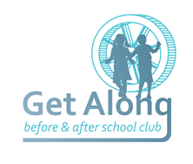

**GET ALONG BEFORE & AFTER-SCHOOL CLUB**

**MILLBROOK PRIMARY SCHOOL**

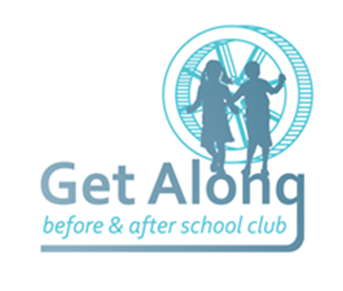**ELMFIELD**

**SHEVINGTON**

**WIGAN**

**WN6 8DL**

**DIRECT LINE 01257 401030**

**CHILDCARE CONTRACT FOR PURCHASED PROVISION IN GET ALONG**

To register your child/children’s names for this service, please read, sign (all sections please) and return to Miss Kay, who will then add them to the online booking system. Sessions are released on a monthly basis and bookings are secured upon payment on a first come first served basis. Places are limited to 45 every morning and afternoon.

**This agreement is between:**

Provider: Get Along Parent/Carer: ______________________

Address: Millbrook Primary School Address: __________________________

Elmfield __________________________

Shevington __________________________

Wigan WN6 8DL __________________________

Email: [ellie.kay@millbrook.wigan.sch.uk](mailto:ellie.kay@millbrook.wigan.sch.uk) Email: _____________________________

**For the care of:**

Child’s full name: _________________________________ Class: _____________

Child’s full name: _________________________________ Class: _____________

Child’s full name: _________________________________ Class: _____________

Date contract to commence: _____________________

**During the period 2nd September 2025 to 17th July 2026**

**Fees:**

|  |  |
| --- | --- |
| **Session** |  |
| **AM 7.45-8.45** | **£4.75** |
| **PM 1 3.15-4.15** | **£4.75** |
| **PM 2 3.15-5.15** | **£7.75** |

**CONDITIONS:**

* **Sessions are booked in advance through the online system – IRIS ParentMail**
* **Fees must be paid at time of booking to secure sessions**
* **Childcare vouchers and The Tax-Free Childcare scheme can be used to pay for sessions – details of how this works are available on request**
* **Sessions can sometimes be booked (subject to availability) on the same day by ringing the direct line and speaking to a member of staff**
* **Cancellations can be made up to midnight the night before the date of the booking through the ParentMail App.**
* **Cancellations on the day are non-refundable**
* **Fees are reviewed periodically, but no increase will be made without at least one month’s notice being given**
* **Breakfast is provided in the mornings and snacks and after-school, drinks are available each session – please advise if your child/children have any food allergies or dietary needs**
* **We stop serving breakfast at 8.30 – any child arriving after this time should have had breakfast before they arrive to be ready to go into class at 8.45**
* **All school policies and procedures apply when children attend GetAlong – parents/carers consent to GetAlong staff caring for their child/children within this framework. Unacceptable behaviour will not be tolerated and we reserve the right to refuse admission where behaviour persistently falls short of The Millbrook Way**
* **GetAlong staff can not take care of sick children, in particular those with an infectious disease, diarrhoea, vomiting and high temperature and can, in consultation with the parent/carer refuse to take a child who appears unwell or is medically unfit to attend**
* **Should a child become ill when in the care of GetAlong, staff will contact a parent/carer, to arrange for their collection and alternative care**
* **An Emergency Contact form must be completed and returned prior to a child’s start date, with up-to-date details of parents/carers who can be contacted in the event of illness/accident – if any details on this form change, please inform a member of staff to update**
* **A password must be provided as an additional security measure in the event of an unfamiliar person picking up**
* **A double session must be booked for any children attending any other extra-curricular activities after school, e.g. Sports Club, who also need to come to GetAlong afterwards**
* **Children must be collected on time GET ALONG CLOSES AT 5.15 PARENTS/CARERS MUST CONTACT GET ALONG IF THEY ARE NOT GOING TO BE ABLE TO PICK THEIR CHILD/CHILDREN UP ON TIME. PLEASE RING THE DIRECT LINE 01257 401030 THERE IS A LATE COLLECTION FEE AFTER 5.15 OF £5 FOR EVERY ADDITIONAL 10 MINUTES.**

**Signed: __________________________ Parent/Carer Date: _________**

**Signed: _______________________ GetAlong Manager Date: _________**