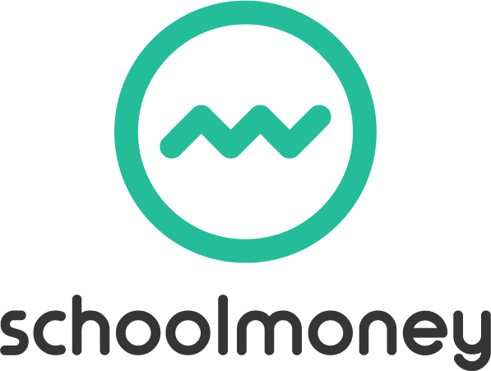
Get Along

Dear Parents/Carers,
Polite notice, we are once again finding that debts are building up and as we are a self-funding service we cannot provide the service without the income. We ask fees are paid in advance providing 2 weeks credit but we have once more found ourselves with over £2,000 outstanding up to half term.
With this in mind we have signed up to the online payment system SchoolMoney, the system you now use for paying for trips, music lessons, toast etc.
This means that contracts you now have will be terminated on Friday 22nd October.
They are replaced with the attached contract which you will need to complete and return to us so that we can enrol your child/children on the online register to enable you to book sessions.
Details of the dates the registers will be opened each half term are on your contract.
On those dates you can book the sessions you need, there will be 40 places available for each session. Sessions are paid for as you book.
You will then book the sessions you need online each half term and pay with your debit or credit card.
Families with accrued credit – this will be transferred over to SmartMoney and show as credit.
Families using Vouchers or Tax Free payment scheme will continue to make payments as you do now, when your payments show on our bank statement we will transfer that payment onto the register which will show as a credit, you can check the credit as it reduces each week and top up as credit is used.
This new payment system will benefit both us as a school and you as a parent. Not only will you be able to book and pay from the comfort of your own home but you will also be able to access your account at any time to see what credit you have.

SchoolMoney will enable us to experience a more streamlined, cost-effective and efficient payment system in a secure and safe environment.
You won’t need to sign up to this system as this is done automatically through the school and as long as you have returned your new contract with up to date contact details we can then add your child/children to the register then you will be able to book sessions for Get Along.
To log into SchoolMoney, visit the website www.eduspot.co.uk and click on the sign in button in the top right hand corner. In the drop down, select the SchoolMoney Parent Login option and this will send you through to a page where you need to enter your mobile number, email address, the password you have been sent and your child’s first name.

If for any reason you are struggling to log in, it may be because you have not provided us with the correct contact details. Please let us know immediately if either your mobile number or email address changes.
We appreciate your cooperation in the early stages of rolling this system out to you.

